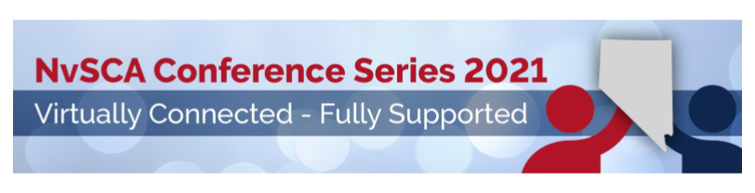
Schedule
Friday, January 29, 2021
7:00pm | Movie Night | Indy Film LIKE and panel

Saturday, January 30, 2021
8:00am-8:15am | General Session
8:15am-9:20am | Keynote (+sponsor) | Helping the Helper - Self Care for Counselors, Allison Edwards
9:20am-10:20am | Breakout Session #1 | Student Success? It's as Easy as T.L.C!
 | Breakout Session #1 | Show NOT Tell: How to Advocate our Value to Stakeholders through Data
10:20am-10:50am | Exhibitors
10:50am-11:50am | Breakout Session #2 | 5 Mistakes Keeping You from Better Health and Well-Being
 | Breakout Session #2 | Virtual School Counseling-Supporting Counselors and Families
11:50am-12:50pm | Breakout Session #3 | Finding your Joy/ Filling your Tank
 | Breakout Session #3 | Using Google Group & Site to Advance How You Connect with Students Virtually
12:50pm-1:00pm | Closing Session
 | On Demand | Tai Chi and Chi Kung for Counselor Wellness
 |  | The Ethical Standards: What you forgot you know
 |  | Title IX Changes and Sexual Harassment - ASCA
 |  | Legal/Ethical Implications of the Hatch Amendment - ASCA
 |  | Making MTSS Work - ASCA
 |  | Develop Surveys & Collect Data with Google Forms - ASCA
 |  | Virtual Middle School Counseling Tier 1 How-to - ASCA
 |  | ASCA National Model: Goals to Mindsets - ASCA

Saturday, February 20, 2021
8:00am-8:15am | Membership Meeting
8:15am-9:20am | Keynote (+sponsor) | Mental Health Literacy: Raising Awareness to Provoke Change, Dr. Julia Taylor
9:20am-10:20am | Breakout Session #1 | How to Have Effective Conversations About Change in Schools
 | Breakout Session #1 | A Case Study in Gratitude: One High School's Schoolwide Approach
10:20am-10:50am | Exhibitors
10:50am-11:50am | Breakout Session #2 | Effective School Mental Health Collaboration: Benefits, Barriers and Solutions
 | Breakout Session #2 | Suicide, Simple Strategies in a Virtual World
11:50am-12:50pm | Breakout Session #3 | We are Ignitors of Hope! Social Emotional Learning is our Fuel!
 | Breakout Session #3 | Trauma Support Groups for Teachers: An Opportunity for School Counseling Interns
12:50pm-1:00pm | Closing Session
 | On Demand | Virtual Calming Room using Google Slides
 |  | SEL Strategies for Counseling Lessons
 |  | Calm Down Kits in Virtual and School Settings
 |  | Understanding Trauma
 |  | Vaping a Crisis in Our Schools
 |  | Preventing Students from Falling Through the Cracks
 |  | Looking at Children through a Trauma Lens: The Programs and Services of The Rape Crisis Center

Saturday, March 6, 2021
8:00am-8:25am | General Session & Awards
8:25am-9:30am | Keynote (+sponsor) | Interrupting Racism: Equity and Social Justice in School Counseling, Rebecca Atkins & Alicia Oglesby
9:30am-10:30am | Breakout Session #1 | #WokeWork: Racial Justice, Equity, and the Role of the School Counselor
 | Breakout Session #1 | Answering Wh"Y"
10:30am-10:55am | Exhibitors
10:55am-11:55am | Breakout Session #2 | Helping and Understanding Boys
 | Breakout Session #2 | Affirmative Approaches to Counseling LGBTQ Youth in Schools
11:55am-12:55pm | Breakout Session #3 | What is an A.N.T.I.R.A.C.I.S.T.?
 | Breakout Session #3 | Workforce Connections
12:55pm-1:00pm | Closing Session
 | On Demand | Cultural Competency for School Counselors
 |  | Benefits of Dual Enrolling (Jump Start)
 |  | ACT & SAT Testing during Corona times
 |  | Gang Awareness and Our Students
 |  | Fostering Diversity within the Healthcare Career Pipeline
 |  | Address Student's Race based Stress and Trauma - ASCA
 |  | Prepare Students for Careers in a Global Economy - ASCA
 |  | Career Exploration and Development with a Focus on Implicit Bias - ASCA

ON DEMAND breakout sessions will be available during the conference and can be viewed until July 31, 2021.

